(Approx. 2,432 words)

Adobe Photoshop Elements 10 & Premiere Elements 10
Reviewed by Clint Tinsley, Editor, Idaho PCUG
November 2011 issue, Bits and Pieces
http://idahopcug.apcug.org/
c_tinsley (at) msn.com

Not a lot has changed since our last look at the Photoshop Elements Family, version 8, in December 2009 and most of what we covered there is still accurate. What I will be covering here is what has been added since 2009 in versions 9 and 10. The four major additions to Photoshop Elements since Version 8 are:

1. Layer Mask Creation - You no longer have to create them manually.
2. Content-Aware Healing Brush - Now you can really make objects disappear, fix old
photos, and fix defects by filling with background that is created from the surrounding area. This one feature alone is worth the price of Elements 10.
3. New in version 10, overlay guides have been added to aid you in cropping your photos using the Rule of Thirds and the Golden Ration. These guides allow you to crop your photos in such a way that the viewer is drawn away from the center of the photo by offsetting the primary focus of the photo against the background. These guides are a welcome addition to Photoshop Elements.
4. Also in version 10 are new guided tasks which include the Michael Orton effect, better Depth of Field adjustments using smart selection tools, and several other improved task oriented adjustments.

I will cover these improvements in some detail as they are definitely valuable additions to the Photoshop Elements family and are reason to consider upgrading to Version 10 from an earlier version if you are already a Photoshop User. I will also comment on the improvements to the Organizer and Adobe Elements Premiere.

The Two Photoshops
Photoshop CS and Photoshop Elements. Photoshop CS is Adobe’s Premiere Professional Photo Editing program and it comes at no small price. Photoshop Elements is sometimes referred to as its little brother as it inherits features and tools from its elder brother. CS is a powerful photo editor and with power comes complexity. Elements is for the photo enthusiast, a consumer level product, where the focus is on ease of use. Elements 10 benefits greatly from its Photoshop CS heritage.
Quick Edit Workspace

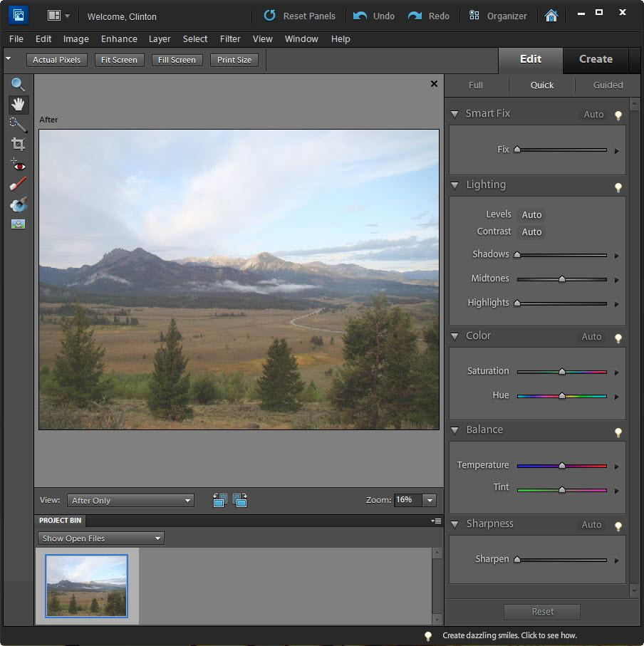
The graphic shows the Quick Edit workspace. As you can see, there are sliders for each of the adjustments you can make here along with the “Auto” smart buttons where Elements 10 will make its best guess at the adjustment. If you don’t like the Auto adjustment, you can undo the adjustment as well as reset all adjustments made here. On the left hand side of the screen are tools for cropping, red eye, teeth whitener, blue sky tool, and the Black & White High Contrast tool for turning a selected area into a high contrast black & white element. The High Contrast tool works by automatically creating a layer mask on the photo and a function from Adobe Photoshop CS to create the effect. Quick Edit provides an easy to use starting point for fixing your photos.
Full Edit Workspace
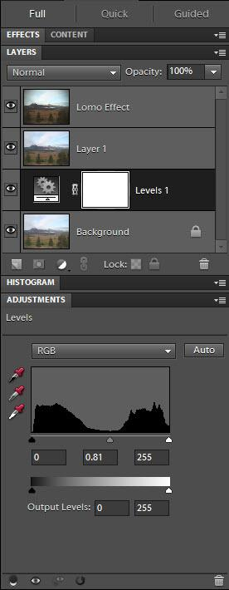
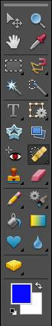
Not a lot has changed here from previous versions. On the left hand side of the work space, you fill find the many tools available to you. Note that many of the tools are actually multi-function as indicated by the little black pointer in the right bottom corner of each tool selection button. Also, on the menu bar across the top are all the different adjustments, filters, plug-ins and effects that Photoshop are known for. On the right hand side are the various panes such as layers and histogram.

Content-Aware Healing Brush

This new feature of the Healing Brush was introduced in Elements 9 and is used by selecting the “Content-Aware” feature from the Brush tool’s option bar shown above. This feature addresses a concern I have had in removing an object from a photo without leaving artifacts behind where the object was or having to do a lot of touch up to make the result acceptable.

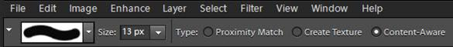

An example: At the top of the next column is a photo of the author at Warm Lake, Idaho. Next to it is the same photo without the author in it. If you did not know where something was removed, it would difficult to know that this was not an original untouched photo.

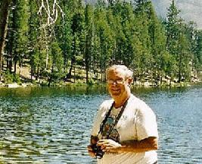

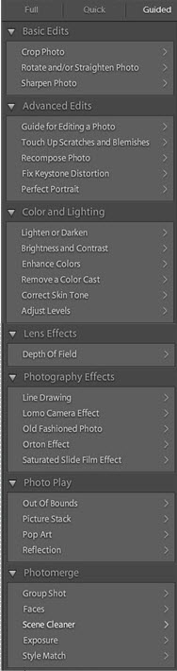
Guided Edit Workspace

At left is a list of most of the tasks that can be performed using the Guided Tasks features. Many of these are an automation of features found in Photoshop CS and automatically create any layers needed as well as perform any adjustments needed to achieve the effect. In the full edit screen shot (above) are the resulting layers that were created when I applied the Lomo Camera Effect to my Stanley Basin Photo. The Guided area is not new to Elements but some new tasks were added that are worthy of mention include the Crop Photo and the Orton Effect. The Crop Photo function now provides overlays for Rule of Thirds and the Golden Guide. These overlays are composition tools that allow you to crop your photo in such a way the viewer is drawn away from the center of the photo by offsetting the primary focus of the photo against the background. The Orton Effect is a dreamy photo effect made popular by Michael Orton. http://www.michaelorton photography.com/. The key to effective use is just the right amount of blur and brightness added to the photo using layers. Here is a flower photo I took at Lake Cascade, Idaho, with the dreamy Orton Effect applied and the layers it created.

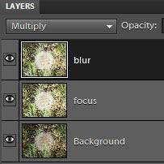

New in Version 10 is a new feature in setting Depth of Field that allows you to set the focus anywhere and on anything in the picture where you want to maintain focus while softening the focus on the rest of the photo.

An extensive set of Photomerge tools are included in Guided Edit (See bottom of Guided Edits List). These tools are useful for merging bracketed photos with Exposure to create “HDR” photos as well as merging content from various photos as well as recomposing photos, even painting out objects in one photo that are not in the other photo. Photomerge is also available from the File menu as a new project including Panoramas. Style Match is where you can apply Photomerge “Styles” to other photos.

For your creative side, Elements 10 adds 30 new smart brush effects and filters along with a new Text on a Path tool where you can surround an object with Text.

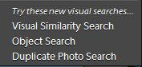
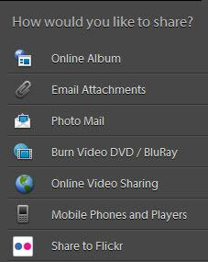
The Elements Organizer is a media management tool shared between both Photoshop Elements and Premiere Elements. Here is where you can manage all your photos and video content with tools to tag and group your content for easy access. Face and object recognition has been added in the version. Face tagging photos for Facebook is now provided. There are three new search options in the Organizer all built around this recognition feature. My photo collection stands at over 12,600 and I know I have a lot of duplicates but the Duplicate Photo Search did not produce usable results. The Visual and Object Search can result in mis-matches and poor results as well. The Organizer Catalog only recognizes changes in content that the Elements applications make including importing photos and other media. If a folder or a file is renamed or modified outside of Elements in using other applications, it is pretty much lost to the Catalog and you have to rebuild the Catalog from scratch. The organizer also provides the ability to share content as shown in the graphic. Online Video Sharing uses Premiere Elements 10 for uploading content to YouTube. The Organizer can be a very powerful tool in managing your photos and videos.

Learning & Using Photoshop Elements 10
Given the popularity of Photoshop Elements as part of the Adobe Family and heir to many tools in Photoshop CS, there is a lot content available along with books to help you learn and use Photoshop Elements 10. Hitting F1 from within the program will bring up the 339 page user manual. Installed with Photoshop Elements is the Inspiration Browser where you can view videos and tutorials on how to perform tasks. On the bottom task bar in Elements, you will get little prompts like this:
Clicking on the prompt will start the Adobe Inspiration Browser and take you to the content however there is a small catch in using this resource. You must have an Adobe ID to use it, the ID is free and you will have many opportunities to create an Adobe ID. If you have a membership in the Plus program, you will have 20 GB for your photos on your personal photoshop.com gallery for sharing your photos.

Shortly after Photoshop Elements 10 was released, there were no less than 6 books available on Amazon specific to using this version of Elements, a real testament in that those books were written before the product was released.

Photoshop Elements 10 Final Thoughts
There is no question that Photoshop Elements 10 is a powerful tool for editing photos and getting creative with your photos. But if you already have Photoshop Elements 8 or 9, or another program that works well for you, then you have to make a decision which is made even more difficult if you already have Elements 9 which introduced the Content-Aware Healing Brush. In any case, you have to decide if the cost is justified in what is an increment upgrade.

Photoshop Premiere Elements 10
Premiere Elements 10 is the video editing side of Elements Family which opens a world of creative sharing of both photos and videos. It shares the all the new features found in the new Elements Organizer for managing, sharing and selecting the content to be used in your video production.

New Technology
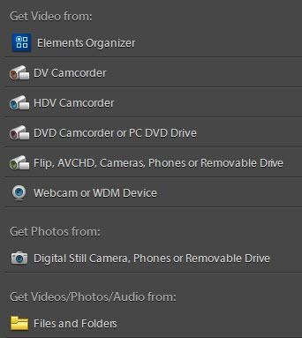
Premiere Elements 10 is a technology release with wider support for more video formats including AVCHD disks. It also takes advantage of new facial recognition technologies in with its new Pan & Zoom tool feature where you can also pan between objects within a photo as well as across faces in a photo. You can easily import from a number of different devices.

Premiere Elements 10 now provides full support for 64-bit Microsoft® Windows® 7 with its own installation set of files. The 64 bit version does not work on Vista which still has to run the 32 bit version. Premiere Elements now provides SmartSound tracks on the Mac.

Making Movies
Premiere Elements 10 is a very powerful video editing system which can turn your photos into interesting movies with menus and titles along with effects and template driven Instant Movies. A new three-way color corrector in Premiere Elements 10 makes it easy to enhance color footage where it can automatically boost tone and vibrancy without affecting skin tones, or you can use sliders to adjust color with complete control. You can now make subtle color corrections by adjusting colors in specific areas, such as highlights, shadows, and mid-tones for perfect color throughout your movie.

Premiere is a non-linear editing system meaning you can add and remove content within a movie. It does not modify your original photos and movies, all the changes to the content made are made within the program. It provides two editing modes, a Sceneline mode where it you can easily drag and drop content in a very visual environment.

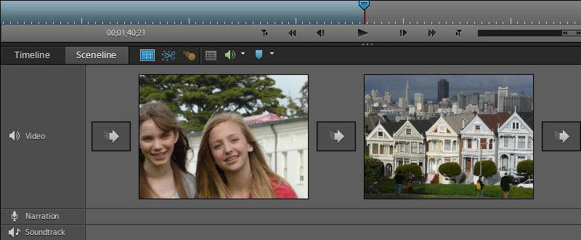

The second mode is the rich Timeline mode where you have the ability to have and edit multiple video and audio tracks in addition to a Narration audio track and a Soundtrack.

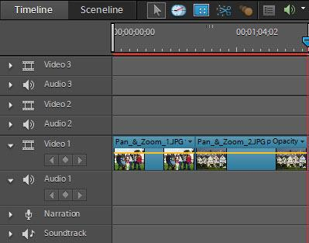

Premiere Elements 10 continues to build on all the features it is known for including green screen effects where you can fly people and objects over other content and motion tracking.

Sharing Features
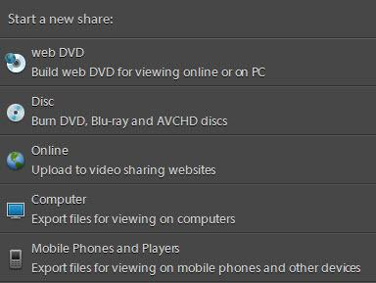
Premiere Elements 10 really shines when it comes to sharing in being able to create and burn a wide range of DVD, Blue-ray and AVHD disks as well as uploading to Photoshop.com, Facebook, and YouTube. And then it takes sharing to next level with its being able to export video to a wider range of cell phones including Apple devices, Smartphones, Mobile Phones, Pocket PC, plus Audio Podcasts, and the Sony PSP device. For each device, it supports different viewing formats and standards. There is also an online organizer by which you can share photos and movies between devices using iPhone and Android apps.

Getting Help
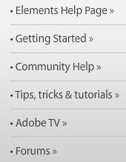
There are many sources of help available to you in Premiere Elements 10. There is a 331 page Using Photoshop Elements 10 manual which you can download at http://help.adobe.com/en_US/premiere elements/using/premiereelements_10_help.pdf. Adobe has a web page at http://www.adobe.com/support/premiereelements/gettingstarted/index.html where you can view a number of videos and web based tutorial pages. From the opening splash screen are links for Getting Started, Community Help, Tips, Tricks & Tutorials, Adobe TV and their Forums.

System Requirements
- 2GHz or faster processor with SSE2 support; dual-core processor required for HDV or AVCHD editing and Blu-ray or AVCHD export.
- Microsoft Windows XP with Service Pack 2, Windows Media Center, Windows Vista® (all applications run native on 32-bit operating systems and in 32-bit compatibility mode on 64-bit operating systems), or Windows 7 (Adobe Premiere Elements Editor runs native on 32-bit and 64-bit operating systems; all other applications run native on 32-bit operating systems and in 32-bit compatibility mode on 64-bit operating systems).
- Color monitor with 16-bit color video card.
- Microsoft DirectX 9 or 10 compatible sound and display driver.
- Windows Media Player (required if importing/exporting Windows Media formats).

Usage Thoughts
There is a lot of technology in Premiere Elements 10 and powerful features means that powerful computing platforms are needed. Even on the fastest computers, you may find yourself waiting on sluggish controls and processing time. Another complaint is that Adobe has not made this product laptop friendly; you have to a bit of scrolling at times to get to choices and controls. I had to move Premiere Elements (as well as Photoshop Elements) 10 to the big screen to capture some of my screen shots. As with Photoshop Elements 10, this is an incremental release, a technology release as I referred to it; There are some new technology and features that make it a worthy upgrade, particularly if you your current video editor doesn't support the latest video formats or makes it painful in exporting your content to your cell phone. Being able to burn Blue-ray content to DVD disks is a definite plus in creating High Definition content.

